1. LG Fault:
2. Line containing fault (4-6, b): A picture containing diagram

   Description automatically generated

1. Line without fault (5-4, a):

1. L-L Fault:
2. Line containing fault (4-6, b):

1. Line without fault (5-4, a):

1. L-L-G Fault:
2. Chart, line chart

   Description automatically generatedLine containing fault (4-6, b):

1. Line without fault (5-4, a):

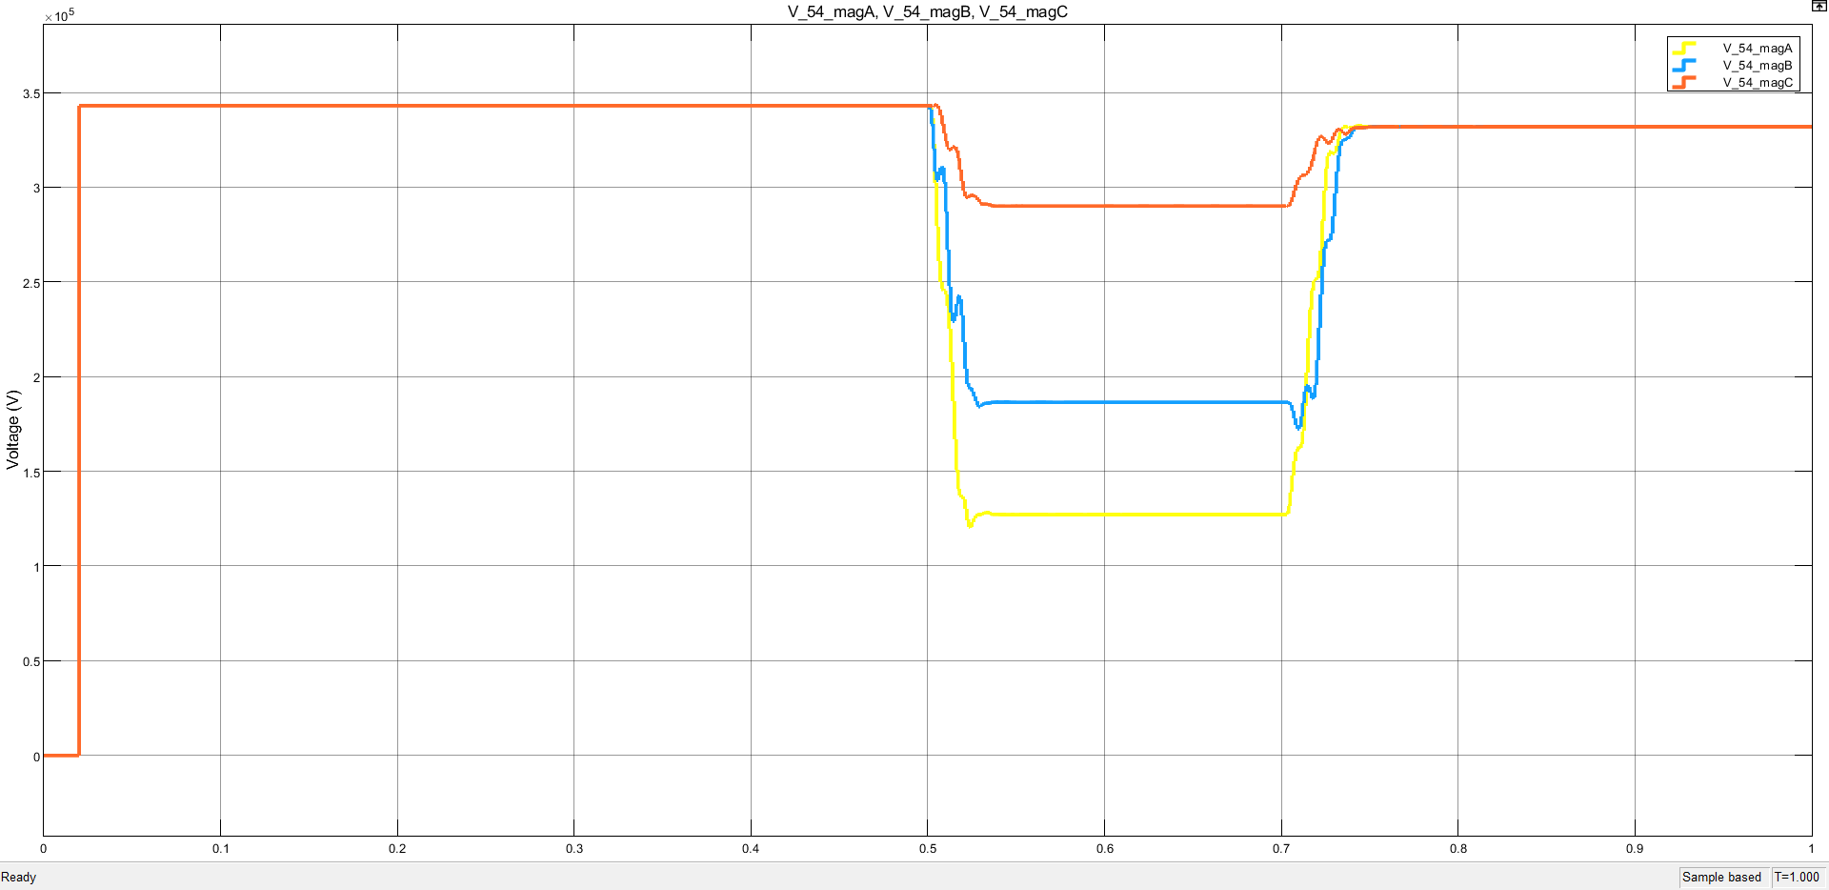

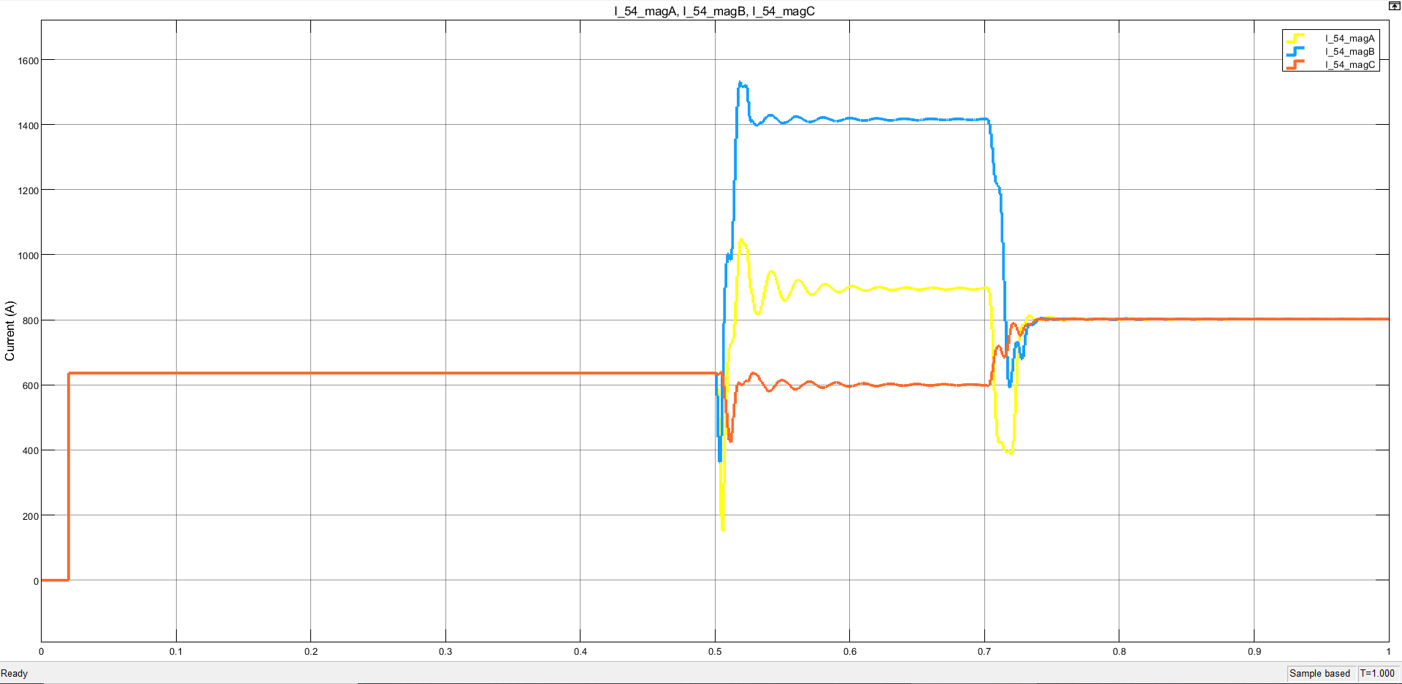

1. L-L-L-G Fault:
2. Line containing fault (4-6, b):

1. Line without fault (5-4, a):

1. L-L-L Fault:
2. Line containing fault (4-6, b):

1. Line without fault (5-4, a):

